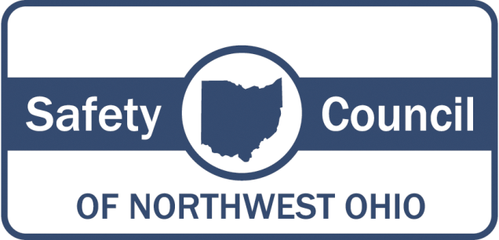

Congratulations to the Graduates of our 2017 COSS® Classes!
The Safety Council of Northwest Ohio is pleased to announce the graduating classes of its curriculum-based certification for Certified Occupational Safety Specialist (COSS®) for August 2017 through December 2017!

COSS® is a week-long accelerated learning, highly intensive, highly interactive, demanding, rigorous course that focuses on providing Safety Practitioners or individuals, who are responsible for safety, with the tools and techniques they need to make safety work for them and achieve results. It is not a course that allows the student to "just sit there and soak it up." It demands that students do homework, participate, read, think, and do problem solving. Daily tests are given as well as a final exam. The students must also develop and present a safety meeting for a grade.

Two of the fundamentals that COSS® addresses are identification and mitigation of hazards and how to use the appropriate regulations to address them, mitigate the hazard, and communicate it to affected personnel. The COSS® course addresses both General Industry and Construction. Further, it addresses the interface that General Industry and Construction have.

The course has gained recognition as a quality program. It has been certified by the American Petroleum Institute (API) and is recognized by the American Council for Construction Education (ACCE). It is being delivered nationwide at multiple locations. Additionally, it has been adapted to a semester format and is a required junior level course at Louisiana State University's School of Construction Management. COSS® maintains a national and international network of Certified Alumni.

These graduates earn the professional designation of COSS® and extensive knowledge in the essential skills and techniques of effective safety and occupational health program management and leadership.
AUGUST 2017
Adam Lowery, COSS
Bret Nitschke, COSS
Bart Howe,COSS
Chad Leslie, COSS
Craig Thomas, COSS
Daniel Turco, COSS
Daniel Crockett, COSS
Deb Frankart, COSS
Elishea Kindred, COSS Elizabeth Macias, COSS Jacob Storrer, COSS
Jake Birkholz, COSS
James Lang, COSS
Joseph Jusko, COSS
Karen MacFarland, COSS Lisa Jackson, COSS
Leo Karcsak, COSS
Linda Lopez, COSS
Rachel Meyer, COSS
Troy Blodgett, COSS

WHIRLPOOL CORP. – CLYDE OPERATIONS
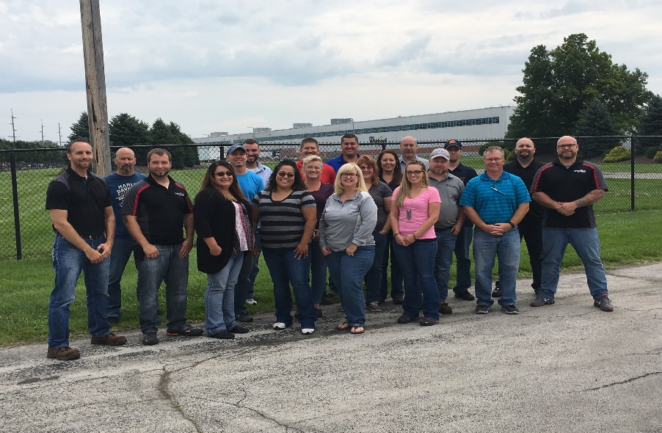

Angela Young, COSS
Angie Jaeger, COSS
Brad Wiltse, COSS
Charles McClenathan, COSS
Chad Stevens, COSS
Craig Feick, COSS
Dorothy Richie, COSS Daniel Kingsborough, COSS Daniel Fondriest, COSS John Bennett, COSS
Jared Funk, COSS
Jennifer Graham, COSS
Kyle Frische, COSS
Lori Frasure, COSS
Melissa Kreh, COSS,
Nathaniel Stayton, COSS Richard Billheimer, COSS Robert Grasley, COSS Sharma Rosenberger, COSS
Tara Davidson, COSS Tammy McGrath, COSS

**********************
OCTOBER/NOVEMBER 2017
Todd Anderson, COSS; The Andersons, Inc.
Don Miller, COSS; The Andersons, Inc.
Arlen Miller, COSS; The Andersons, Inc.
Derek Besgrove, COSS; BP-Husky Refining
Tom Menden, COSS; BP-Husky Refining
LaRhonda McCoy, COSS; City of Toledo
Eric Sutton, COSS; Fragrant Fowl, LLC
Erica LaPan, COSS; Geddis Paving & Excavating Joseph Ramey, COSS; GKN Driveline, BG
Shireen Fakhari, COSS; Henry Gurtzweiler, Inc. Rodney Baugher, COSS; HydroChem
Kenneth Turner, COSS; J. Ranck Electric
Jeffrey Houssami, COSS; Ohio Dept. of Trans.
Herbert Hatter, COSS; Whirlpool Clyde Operations Marcy Baker, COSS; Whirlpool Clyde Operations
Michael Fought, COSS; Whirlpool Clyde Operations Gary Mears, COSS; Whirlpool Clyde Operations
Dan Gusching, COSS; Whirlpool Findlay Operations

***************************
NOVEMBER 2017 – CLEVELAND
Bernadette Romantic, COSS; Athens Foods, Inc.
Sandra Harrell, COSS; Cleveland Metro School Dist.
Andrea Bester, COSS; Cuyahoga Bd. of DD
Laura Kubulins, COSS; Cuyahoga Bd. of DD
David Nodge, COSS; Cuyahoga Bd. of DD
Alison Sauer, COSS; Cuyahoga Bd. of DD
Michelle Fry, COSS; Hunter Defense Technologies
Jeff McConeghy, COSS; HX5/Sierra
Vincent Puletti, COSS; Ohio Dept. of Transportation
Matthew Conner, COSS; Parker Hannifin
Chris Alcorn, COSS; Parker Hannifin TFD
Edward Davidson, COSS; The Bonitz Co. of Carolina

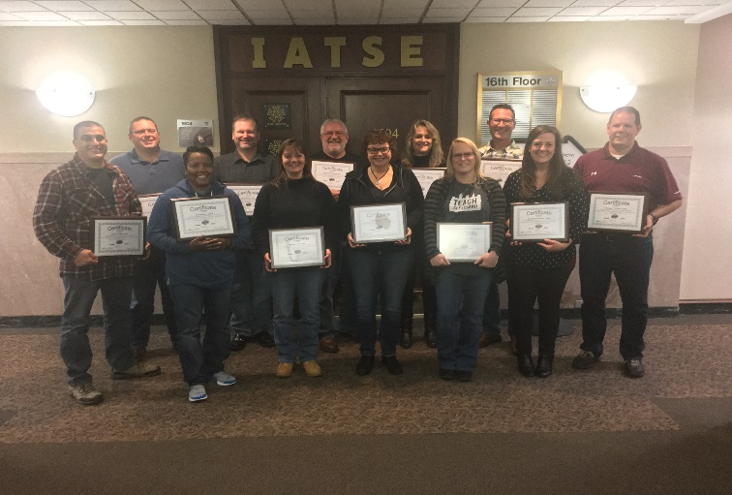

*******************************
DECEMBER 2017
Corey Wholf, COSS; The Andersons, Inc.
Eric Myers, COSS; BP-Husky Refining
Karis Williams, COSS; Campbell, Inc.
Frankie Applegate, COSS; Fisher Contracting Inc.
Justin Fox, COSS; Hirzel Canning Co. & Farms
Nicholas Niezgoda, COSS; Hoover & Wells Inc.
Derek Tighe, COSS; JJ White, Inc.
Gary Martin, COSS; Laibe Electric Co.
Brian Thomas, COSS; Matrix Technologies Inc.
Craig Morse, COSS; Mercy Health
Etsubteru Assefa, COSS; Pilkington NA
Todd Balser, COSS; Spartan Steel Coating
Michael Fitch, COSS; Toledo Tool & Die Co.
Riad Okdie, COSS; Uckele Health & Nutrition
Jeanne Kreh, COSS; Whirlpool Findlay Operations

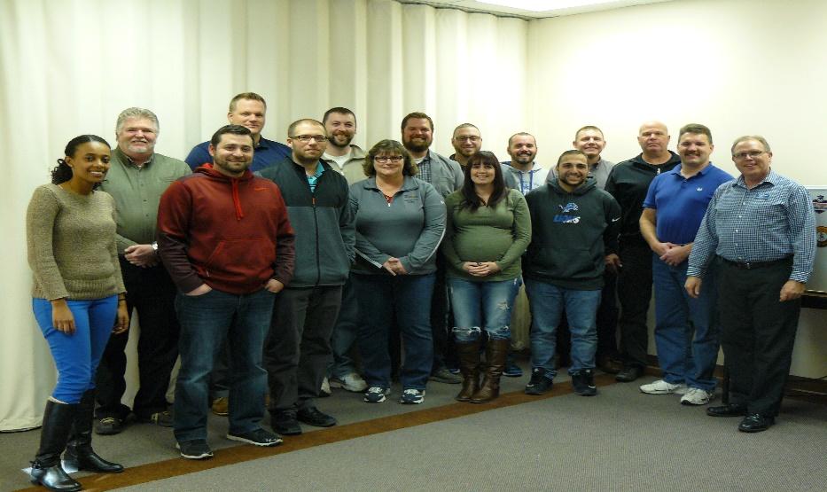

For information on our COSS® classes offered in 2018, please contact us.

Safety Council of Northwest Ohio
8015 Rinker Pointe Ct.
Northwood, OH 43619
(419) 662-7777
(419) 662-8888 fax
“Your Premier Safety Resource”

