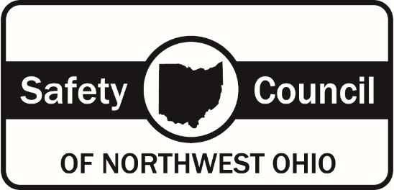

8015 Rinker Pointe Court, Northwood, OH 43619 ● 419.662.7777

You are registered to take a State of Ohio approved Adult Defensive Drivers 8-hour Course

Your scheduled course date is Friday

This course meets the requirements set forth by the State of Ohio Remedial Driving Program. The fee for this course is $95 per
person. This course is conducted in English and the course consists of lecture, paperwork, bookwork, videos and class participation
which each student is required to take part in. A test is administered at the conclusion of the class that each student must pass by a
minimum of 75% in order to receive a certificate of completion. If a student does not pass the initial test, they will be given an
additional opportunity to retake a different version of the test, before they will be required to retake the course at an additional fee.
Students caught cheating will be removed from the class and forfeit any paid fees.

Information obtained will be used only by the Safety Council of Northwest Ohio, the State of Ohio and any other entity listed below
under "reason given for taking the course". These records are kept on file for a period of 3 years and will then be properly disposed.

This course will begin promptly at 8:00 a.m. and will conclude at approximately 5:00 p.m. please be here by 7:45 a.m.

This course will be conducted at the Safety Council of Northwest Ohio training facility at: 8015 Rinker Pointe Court (near Owens
Community College), Northwood, Ohio - use the side classroom entrance.

You are required to bring a photo ID with you to class. Cell phones and electronic devices are not permissible during class times.

If for any reason, you will not be able to attend the class you are scheduled for, you must notify our office prior to 4:00 p.m. the
Thursday before your scheduled class date at (419) 662-7777 to avoid losing your paid fees.

The course fees are NON-REFUNDABLE.

- If you do not show for the class you are scheduled for, you will forfeit your paid fees.

- If you arrive after the class has begun you will not be admitted and you will forfeit your paid fees.

- Disruptive students or those under the influence of drugs or alcohol will not be admitted and can be removed from the class and will forfeit any paid fees.

- If an emergency occurs and a student must leave during class, they will be rescheduled for the next class at no charge and must retake the entire course. The student must discuss the emergency and get approval from the instructor prior to leaving the class.

- If for any reason a class needs to be cancelled due to extenuating circumstances, you will be contacted and rescheduled at no additional fee.

It is advisable to bring a lunch with you; a refrigerator & microwave are provided. Pop, coffee and vending machines available on
site.

If a student has a grievance, please discuss it with the instructor first. If the issue cannot be resolved with the instructor, please
contact the office. If after discussion with the instructor and office, we do not satisfy your grievance you should contact the Ohio
Traffic Safety Office (OTSO) at: 1970 West Broad Street, Columbus, Ohio 43223

If you have any questions, please feel free to call during our scheduled office hours of 8:00 a.m. - 4:00 p.m. Monday - Friday

Reason given for taking the course:

12 point suspension** 2 point credit

Work related Out of State violation, State: _____________________

Court Ordered, Court location:________________________________________________________

Miscellaneous: ____________________________________________________________________

** If you need a replacement certificate, there is a $20 fee.

I understand and agree to the items listed above
and all of my questions have been answered to my satisfaction

Student Signature:

Student Name:
(Print Clearly)
Date: _ ________________ School Official
**If course date is changed, this agreement stays in effect

